**WORD COUNT 3000**

**TITLE Apple (Essay)**

TABLE OF CONTENTS

Introduction 3

Overview of Apple Inc. 3

The Market-Activated Corporate Strategy (MACS) 4

Evaluating the Strengths and Weakness of the MACS Model 6

Analysis of Apple Inc. Sales Data 7

Using MACS Matrix to Analyse Apple Inc.’s Move to Increase or Extract Value 10

Recommendations 12

Conclusion 13

References 13

# 

# Introduction

Strategic management is one of the most crucial aspects of an organization; it determines how an organization intends to cope with the competition in the business environment and gain a competitive edge against the many rivals in the industry (Saloner, 2018). According to Bateman (1979), one of the objectives of an organization is to perform better than its rivals; this performance is however achieved by gaining a larger percentage of the market share, however, to improve its market share, an organization must make adequate plans and subsequent actions to perform better. The organization can improve its performance by conducting a situational analysis which enables it to identify its strong points and optimise these areas to further its performance, however, the situational analysis also helps the organization to identify its weaknesses and thus makes plans to improve those areas (Richardson, 1993). Moreover, a situational analysis helps the organization to create strategies to identify its competitive position against contemporaries and thus help it to tailor its products and services to maximise its outcomes and improve its competitive position (Clarke, 2014).

According to (Saloner, 2018), organizations must put adequate places in motion to be successful in the competitive marketplace; this is only achieved by an effective corporate strategy, however, the corporate strategy of the organization must be integrated at all levels of the organization. The corporate strategy of the organization determines its business expansion strategies such as acquisition, mergers among others.

This essay seeks to analyse the strategic management of Apple Inc., it will first give an overview of the company and the MACs framework, it will further analyse the strategic moves of the company and how it performed between 2012, 2013 and 2014.

# Overview of Apple Inc.

Apple Incorporated is one of the biggest tech companies worldwide; it focuses on the design, development, sales and distribution of technological products (Levy, 2021). Its range of product offerings includes consumer products like smartphones, electronics and computer systems; it also includes computer software programs and online services (Levy, 2021). Apple Inc gained global recognition following its development of the iPhone; however, it is also notable for producing iPad, iPod, Airpods, Mac Personal computers, Apple Watch series and HomePod. Additionally, the company has been able to strategically distinguish itself from various competitors in the market by developing its operating system software like the macOS and iOS; these systems are used for its products (Apple, 2021). The company also offers cloud services, digital content and online payment services; the company has gained recognition in the market by targeting a particular segment of the market, that is, the consumers, medium-sized organizations, educational firms, large organizations, governmental institutions (Levy, 2021).

Strategically, Apple Inc. has been successful in the global market by focusing on its unique product development process which also forms one of the critical factors that has been able to improve its growth and performance in the market (Levy, 2021). Its business model encourages its consumers to use the available technologies in the market which also allows the company to focus on producing the best products and offering those for sale at prices that guarantee optimal profits (Levy, 2021).

One of the major milestones of the company was its growth in 1980; its value at the time had grown to over 100 million USD and over 1000 staff strength; however, in the same year, the company lost its competitive position to IBM but through innovation, the company has been able to grow back to claim its competitive position (Levy, 2021).

# The Market-Activated Corporate Strategy (MACS)

The Market Activated Corporate Strategy emerged in the late 1980s, however, it was developed as a strategy that improves obsolete frameworks that are used to analyse an organization's market growth rate and share; one of such models is the BCG Growth-Share matrix- the BCG framework divides an organization's business units into different categories and then analyses them to ascertain the profitability and growth of the organization (Francis, 2013).

Similarly, the nine-box matrix model developed was aimed to analyse an organization’s product market (McLeod & Stuckey, 2000); however, this model has its shortcomings as it does not offer a comprehensive approach to analysing an organization's investment decisions and this led to the development of the MACS approach by McKinsey. MACS focuses on providing organizations with a model that allows organizations to appraise their investment decisions and prioritize them according to the resources available to the organizations. According to (Francis, 2013), there are three major decisions that organizations can make using this approach, once the organization has appraised its investments, the model helps the organization to sell, buy or retain its investments.

McLeod and Stuckey (2000) note that these decisions are made by the organizations based on the level of value that these investments can offer the organization as well as the level of attractiveness of such investments in the business environment. Furthermore, once an organization has determined that it can capture value, investment decisions can be to buy or retain the business unit, on the other hand, if the organization has determined that the investment has no value to offer, the investment decision can be to sell off the investment to potential owners.

Moreover, the MACS framework shares similarities with the nine-box matrix model in that the charts contain both vertical and horizontal axes which are used to describe an organization’s propensity to capture value from the business unit relative to competitors (Francis, 2013). However, the distinguishing characteristic of the models is that the horizontal axes have been merged to show the propensity of an organization to establish the value as a single unit (McLeod & Stuckey, 2000). The MACS model is then useful for organizations to evaluate their business segments and allocate resources optimally.

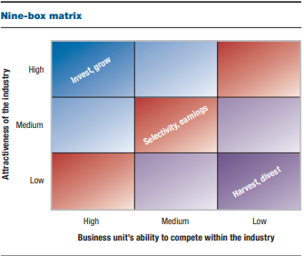

Figure 1: Nine-Box Matrix Model

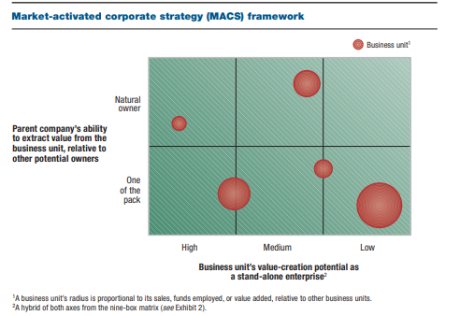

Figure2: Market-Activated Corporate Strategy Model

## Evaluating the Strengths and Weakness of the MACS Model

MACS provides benefits for an organization; it helps organizations to analyse every segment of their businesses to determine if such segments are profitable, that is, if they are capable of creating value for the organization (Francis, 2013). This is a major advantage over older frameworks of appraising investment decisions; the nine-box matrix model, for instance, focuses on analysing only the level of attractiveness of an industry and the competitive position of the parent company (McLeod & Stuckey, 2000). MACS model, on the other hand, analyses the ability of a business unit to create value and the ability of the parent company to extract value relative to the competitors in the industry (Francis, 2013); thus it facilitates planning, investment appraisal and decision making.

Conversely, the disadvantage of this model is that it is more effective for large organizations leaving behind small and medium-sized organizations; this is because these large organizations have the financial muscle to invest in different portfolios whereas small and medium-sized organizations are majorly focused on making some level profits and surviving the intense business environment without financial resources to acquire other business units.

# 

# Analysis of Apple Inc. Sales Data

Apple Inc. has gained prominence since it has entered the technology market; the company has experienced tremendous growth in the industry with its revenue growing from about 8 million USD to over 274 billion USD between 2004 and 2019 (Levy, 2021); this is a more than its contemporaries in the industry like Google and Microsoft. However, the growth of the company did not start in a day as it has experienced its share of flops and market failures especially in its attempt to develop and market personal computers and mobile devices. The sales data for its iPhone series between the years 2012 and 2014 shows that the company has been experiencing a steady increase in sales; towards translating to the fact that the company is capturing value from the development and sales of its iPhone series; according to Statisa (2021), the company experienced stable sales since it introduced its first generation of iPhone in 2007 as shown in figure 3 below:

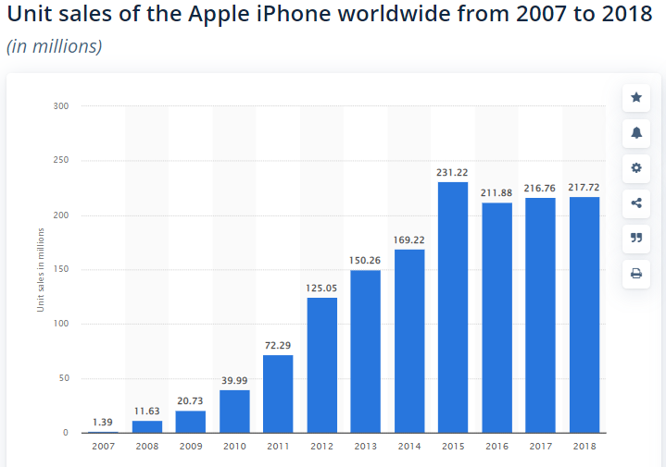

Figure 3: Unit Sales of Apple iPhone Worldwide between 2007 and 2018

Source: Statista (2021)

According to Statista (2021), the iPhone series contributes about half of the total sales revenue of the company; the steady increase in sales of the iPhone series over the years have made the company the most profitable phone manufacturer while Samsung follows closely behind.

Similarly, Apple Inc.’s line of iPods has also contributed to the growth of the company since its inception. The iPods are designed to revolutionize the music industry by aligning software and hardware in a pocket device; according to Statista (2021), the development of the iPods formed some of the greatest successes of the company. From the figure 4 below, the sales of the company grew steadily from 2006 and it reached its peak in 2008; conversely, sales of iPods have decreased steadily since then but was significant in 2012with sales reducing steadily in the following year 2013 and 2014 (Statista, 2021). However, the decline in sales can be attributed to the introduction of its iPhone series and the increasing trend of smart devices which offers similar services to the iPod.

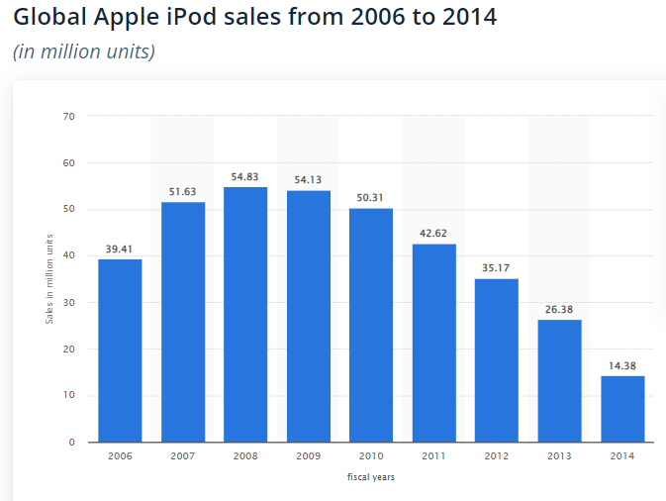

Figure 4: Global Apple iPod Sales from 2006 – 2014

Source: Statista (2021)

Despite the decline, Statisa (2021) reported that iPods contributed about 1% to the total sales revenue of Apple Inc. as shown in figure 5 below. This implies that the business unit or portfolio is losing its ability to create value for the company as it has little contributions to the total revenue of the company relative to the cost of production of these products, additionally, the company’s ability to extract value from this business unit is slim as it as other product lines that creates more value and market success for it as shown in Figure 5.

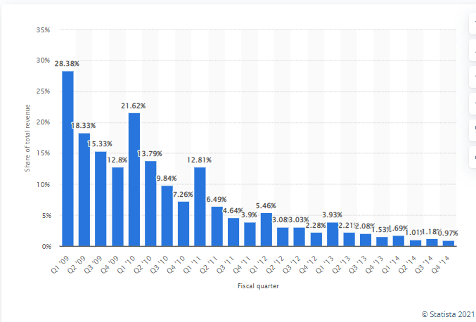

Figure 5: iPod revenue as a share of Apple's total global revenue from 1st quarter 2009 to 4th quarter 2014

Source: Statista (2021)

Apple Inc.'s line of products also includes the iPad series which was introduced in 2010; the first model being the iPad Air 2; the sales during this period following into 2012 increased steadily as the product performed well in the market; Statista (2021) reported that the product was a dominant force in the market at this time as it had about 58.1% share of the market. Furthermore, the sales of the product continued to grow in the market despite fluctuations in sales performance in between the fiscal years. This also implies that the iPad provides great value for Apple Inc as Goldman (2012) noted in his article that the company was able to sell about 3 million units of iPad barely four days after it was released thus making it the most successful launch for the product line. However, the sales for the iPad peaked in 2014 and sales declined in the following years as shown in Figure 6 (Statista, 2021; Nations, 2021).

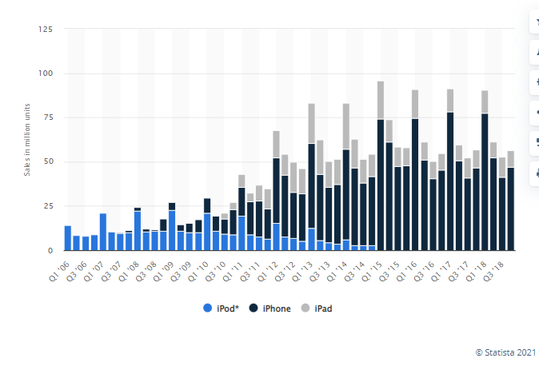

Figure 6: iPhone, iPad and iPod sales from 1st quarter 2006 to 4th quarter 2018

Source: Statista (2021)

# Using MACS Matrix to Analyse Apple Inc.’s Move to Increase or Extract Value

Apple Inc.'s purpose is to offer products that enrich the lives of its consumers; this is notable in its products offerings as its products are noted to improve consumers' lives by providing them with easy access to technological products (Levy, 2021). The company also consistently does this by developing new models of smartphones, tablets, pods, PCs and several other products. The company’s resilience in becoming a notable player in the telecommunication and smartphone industry has finally paid off considering that its products, especially its iPhone series has performed remarkably well in the industry (Statista, 2021). The product offerings of the company are in various categories ranging from consumer electronics that ranger over smartphones, personal computers, wearables, and phone and PC accessories. Furthermore, considering that Apple Inc. has been able to distinguish itself from other competitors in the industry; its products have been able to gain acceptance and thus improving the sales revenue of the company (Levy, 2021); this way the company has been able to take over the market winning over Android Smartphones; thus competing fiercely against Samsung Electronics (Lunden, 2015).

The company has had its share of challenges since its inception; according to Colt,(2014), some of the products introduced in the market especially in its early shares failed to gain market acceptance, some of these products include the Apple III; however, the success of the company started with its release of the first Mac PC. The success of this product in the market was its ability to create value following the MACS framework, the product line could gather sales (value) which in turn created profits for the company, however, on the other hand, the product line needed to fulfil the need of the customers; thus, customer satisfaction as a necessity. Critically, evaluating the product line, the business radius is located on the top left of the MACS matrix; indicating that the ability of the company to extract value is high and the ability of the product line to create value is high.

Furthermore, there was a need for the company to dominate the consumer segment of the market; this necessitated developing products to suit the needs of the larger populace such as the iPhone series. The company's iPhone has created tremendous value in the marketplace and has thus become significantly powerful such that it cannot be replaced; due to the sales performance of the first iPhone in the market, it attracted the company to extract further by investing more in research and technology to improve the quality of the series (Leswing, 2019); the author further noted that the company has sold over 1.4 billion iPhones in the last decade. Using the MACS framework, the iPhone has a high ability to create value as a standalone business unit and the company has the high ability to extract value from the business unit thus placing it at the top left of the matrix.

Apple Inc.’s Ipad series was introduced in 2010 to fulfil a need in the market; however, there has been a reduction in sales of the products after it peaked in 2014 (Nations, 2021); this implies that there has been a reduction in the portfolio’s ability to create value as a stand-alone business even though the company has a high ability to extract value from the business unit even though it had a high-value impact in the beginning. Hence, following the MACS framework, the iPad business unit is located on the top right of the matrix.

Moreover, the iPod was introduced in the market to make the musical experience seamless for consumers and at the point of introduction into the market, the business unit had a high value as it formed one of the greatest successes of the company (Statista, 2021); however, its value reduced in 2008 following the development and introduction of iPhones in 2007. At this point, the sales of the company went down the drain and its reduction peaked in 2012. This implies that the business unit’s ability to create value is low even though the company has a high ability to extract value from the business unit; hence, according to the MACS framework, the business unit is located on the top right of the matrix.

The distinctive characteristic of the company relative to its competitors in the industry is its business strategy; the company uses a vertical integration model that ensures that the company designs, produces and sells all of its products; according to GreyB (2021), this strategy combines the company's design capability and expertise in hardware and software to build a positive ecosystem. Additionally, another key competence of the company is the development and utilization of this operating system; the iOS and the macOS which are used in its smartphones and PCs.

# Recommendations

It has been identified that of all three portfolios managed by Apple Inc. in this essay, its iPhone is of the greatest value while the iPad and iPod have low propensities to create value for Apple Inc. the following recommendations are made given these findings.

* The company has been identified to use a vertical integration strategy in its production and this has proven to be beneficial to the company, however, it is recommended that the company invests heavily and better in technological innovations to further distinguish its offerings from those of competitors.
* It is also recommended that the company sells its iPods considering that the emergence of smartphones has overhauled the use of iPods; smartphones have come to harmonise their distinctive features with those of the iPods.
* Additionally, the iPads have decreased in value, however, it is recommended that the company retain this business unit as it still has the potential to increase in value in future. However, it would require that the company invests in redesigning the product to maximise the value it has to offer.

# Conclusion

Organizations strive to improve their competitive position in the fierce business environment; however, this is almost impossible without a concrete and comprehensive strategy that guides the operations and investments decisions of the organization. The investment decisions made by an organization are hinged on the scarcity of available resources; hence, the organization must analyse these investment options based on their ability to be profitable and valuable for the organization and thus use that information to guide the allocation of resources. Apple Inc. has made several strategic decisions to maximise the outcomes of its investments and gain a competitive position in the industry; one of the moves made by the company is the development of its iPhone series after several market failures, this business unit has made the most contributions to the company's revenue and growth. Other product lines like the iPad and iPod had great value-creation potential at the beginning; however, the value-creation ability decreased as sales of both product lines plummeted. Overall, investing in these three product lines brought Apple Inc. to the limelight and helped it gain a competitive advantage over competitors like Samsung and Google.

# References

Apple, 2021. *Apple*. [online] Apple. Available at: <https://www.apple.com/> [Accessed 23 December 2021].

Bateman, A., 1979. *Organizational objectives*. [Brookings, S.D.]: Cooperative Extension Service, South Dakota State University.

Clarke, A., 2014. *Grounded theory and situational analysis*. Los Angeles: SAGE.

Francis, A. (2013) *Market Activated Corporate Strategy (MACS) Framework - MBA Knowledge Base*. Available from: https://www.mbaknol.com/strategic-management/market-activated-corporate-strategy-macs-framework/#:~:text=MACS%20(Market%20Activated%20Corporate%20Strategy,investments%20among%20its%20business%20units. [Accessed 23 December 2021].

Goldman, D., 2021. *Apple sells 3 million new iPads in 4 days*. [online] CNNMoney. Available at: <https://money.cnn.com/2012/03/19/technology/apple-ipad-sales/index.htm> [Accessed 23 December 2021].

GreyB, 2021. *Apple Business Strategy: A Detailed Company Analysis - GreyB*. [online] GreyB. Available at: <https://www.greyb.com/apple-business-strategy/> [Accessed 23 December 2021].

Leswing, K., 2019. *The iPhone decade: How Apple’s phone created and destroyed industries and changed the world*. [online] Available at: <https://www.cnbc.com/2019/12/16/apples-iphone-created-industries-and-changed-the-world-this-decade.html> [Accessed 23 December 2021].

Levy, S., 2021. *Apple Inc. | History, Products, Headquarters, & Facts*. [online] Encyclopedia Britannica. Available at: <https://www.britannica.com/topic/Apple-Inc> [Accessed 23 December 2021].

Lunden, I., 2021. *iPhone overtakes android in us sales for the first time since 2012*. [online] Techcrunch.com. Available at: <https://techcrunch.com/2015/02/04/apples-iphone-overtakes-android-in-us-sales-for-the-first-time-since-2012/> [Accessed 23 December 2021].

McLeod, K. and Stuckey, J. (2000) Available from: https://www.mckinsey.com/business-functions/strategy-and-corporate-finance/our-insights/thinking-strategically [Accessed 23 December 2021].

Nations, D., 2021. *Did You Know This Many iPads Had Been Sold?*. [online] Lifewire. Available at: <https://www.lifewire.com/how-many-ipads-sold-1994296> [Accessed 23 December 2021].

Richardson, J., 1993. *Situational analysis*. Raleigh, N.C.: N.C. Cooperative Extension Service.

SALONER, G., 2018. *STRATEGIC MANAGEMENT*. [Place of publication not identified]: JOHN WILEY.

Statista, 2021. *Apple iPod sales 2006-2014 | Statista*. [online] Statista. Available at: <https://www.statista.com/statistics/276307/global-apple-ipod-sales-since-fiscal-year-2006/> [Accessed 23 December 2021].

Statista, 2021. *Apple product sales (iPhone, iPad & iPod) 2009-2018 | Statista*. [online] Statista. Available at: <https://www.statista.com/statistics/253725/iphone-ipad-and-ipod-sales-comparison/> [Accessed 23 December 2021].

Statista, 2021. *iPhone sales by year | Statista*. [online] Statista. Available at: <https://www.statista.com/statistics/276306/global-apple-iphone-sales-since-fiscal-year-2007/> [Accessed 23 December 2021].

Statista, 2021. *iPod revenue as a share of Apple's total revenue 2009-2014, by quarter | Statista*. [online] Statista. Available at: <https://www.statista.com/statistics/253630/ipod-revenue-as-share-of-apples-total-revenue/> [Accessed 23 December 2021].